Adaptive Gamification and Ontological Modeling for Optimizing Retention in Personalized MOOCs

Abstract— Massive Open Online Courses (MOOCs) continue to face persistent challenges in maintaining learner engagement and sustained motivation, often leading to high dropout rates. This study introduces a novel personalization framework that adaptively integrates gamification elements such as leaderboards, badges, and points based on individual learner profiles. By combining artificial intelligence techniques, including learner clustering, with semantic web technologies, the proposed approach delivers context-aware and personalized learning pathways. The framework is implemented through a web-based platform LevelUp, which features a dynamic learner profiling engine, modular content organization, adaptive gamification mechanisms, and a pedagogical ontology enabling semantic alignment between learner characteristics and game mechanics. Experimental results reveal significant improvements in learner motivation, engagement, and retention. This research highlights the critical role of ontologies in MOOCs for supporting intelligent decision-making and advancing the effectiveness of personalized online learning environments.

Keywords—Gamification, MOOCs, Personalization, Retention rate, Learner characteristics, Ontology.
- INTRODUCTION
Since Massive Open Online Courses (MOOCs) have transformed the landscape of education by offering accessible, large-scale, and flexible learning environments. However, despite their popularity, MOOCs continue to face persistent challenges most notably low retention rates, limited engagement, and the lack of sustained learner motivation [1]. These issues are exacerbated by the inherent diversity of MOOC participants, who come from varied cultural, educational, and professional backgrounds and possess differing levels of prior knowledge, learning preferences, and goals.
Compared to traditional e-learning systems, MOOCs require more scalable and adaptive solutions to address learner heterogeneity. Personalization has emerged as a key strategy to meet this need. It involves adapting learning paths, content delivery, and support mechanisms based on learner profiles such as cognitive styles, performance data, and behavioral patterns [2] [3].Yet, implementing effective personalization in MOOCs is highly complex due to the massive number of learners and the variability of relevant parameters to consider [4].
In parallel, gamification has gained significant traction in online education for its potential to stimulate engagement and intrinsic motivation. By introducing game elements such as points, badges, leaderboards, and progress tracking gamification transforms passive learning into active and rewarding experiences [5]. In large-scale environments like MOOCs, where direct instructor interaction is minimal, gamification can encourage collaboration, competition, and self-regulated learning.
Recent research suggests that integrating gamification with intelligent personalization can yield significant improvements in learner satisfaction and outcomes [6]. However, current approaches often fall short due to limited real-time adaptation and insufficient semantic alignment between learner traits and gamified content. Moreover, the selection of personalization variables remains inconsistent, raising questions about which learner characteristics most effectively guide adaptive strategies in MOOCs [7].
To address these gaps, this study proposes a novel framework that fuses semantic technologies, artificial intelligence, and gamification within a personalized MOOC environment. The framework leverages a multi-layered approach that includes:
- dynamic learner profiling,
- ontology-driven semantic mapping,
- adaptive gamification, and
- real-time content recommendation.
Implemented through the LevelUp platform, the proposed system supports scalable, behavior-sensitive personalization. It matches individual learner profiles with gamified instructional strategies to enhance motivation, engagement, and retention.
This work is guided by the following research questions:
- How can e-learning outcomes be improved in MOOCs through personalized interventions?
- In what ways does gamification impact retention and motivation in MOOCs?
- What are the most effective learner characteristics to consider when designing personalized learning paths?
- How can semantic web and AI technologies be leveraged to operationalize these strategies at scale?
By exploring these questions, this study aims to contribute both theoretically and practically to the design of adaptive, personalized MOOCs. It highlights the importance of aligning gamification mechanics with learner profiles and pedagogical goals and provides an evidence-based roadmap for enhancing MOOC effectiveness through intelligent, data-driven strategies.

- RELATED WORK
This section presents an in depth review of the state of the art research in MOOCs, focusing on the integration of gamification and personalization in e-learning. The review is structured into four main parts: MOOCs and their challenges, personalization in MOOCs, the evolution of e-learning toward personalized MOOCs, and contemporary approaches addressing learner engagement and retention.
- MOOCs and Their Challenges
Massive Open Online Courses (MOOCs) are digital learning environments that offer open and flexible access to education. They gained prominence in the early 2010s through platforms such as Coursera and edX. While they democratized education by overcoming geographical and financial barriers, MOOCs still face persistent issues, including low retention and limited learner engagement. The open nature of MOOCs attracts a highly diverse learner population, which complicates the provision of a one-size-fits-all educational experience. MOOCs must now evolve to address both explicit knowledge (easily transmitted through content) and tacit knowledge (embedded in learner experience). This necessitates dynamic, adaptive learning environments capable of personalizing instruction based on learners' evolving profiles [8].
- Personalization in MOOCs
Personalization is seen as a key strategy to improve engagement and reduce dropout rates in MOOCs. [9] Analyzed learner behavior and suggested adaptive content delivery tailored to individual needs. [10] Further proposed predefined learning paths and achievement systems, such as super badges, to maintain motivation.
Other scholars, such as [11] and [12], highlighted the commercial and business model implications of personalization in MOOCs, arguing for better data sharing and learner profiling. However, despite the recognized importance, [13] and [14] pointed out that few MOOC platforms currently implement robust personalization mechanisms. The POOC (Personalized Open Online Course) concept has been discussed, but practical implementation remains limited.
Table 1 provides representative examples of personalization efforts in MOOCs:
Table1: Exemples of personnalisation efforts in MOOCs
Researchers | Personalization Approach
[14] | Competency-based personalization matching content to learner knowledge levels
[15] | Adaptive planner supporting learners with low self-regulation in MOOCs
[16] | Recommendation system tailored to learner preferences
[17] | Pedagogical framework and scalable architecture for adaptive MOOC delivery
Table 1 shows examples of personalization in MOOCs, such as matching content to learners’ knowledge, supporting low self-regulation, recommending resources based on preferences, and using adaptive frameworks for course delivery.
- E-Learning Toward Personalized MOOCs
E-learning originally referred to computer-assisted instruction delivered via electronic platforms. With technological advancements, it evolved into interactive, flexible, and student-centered learning systems. Unlike traditional face-to-face methods, e-learning adapts content, pace, and assessments based on learner profiles.
Gamification has emerged as a crucial component in enhancing motivation. Tools such as leaderboards, badges, and points systems introduce game mechanics into learning environments. Authoring tools allow educators to design interactive scenarios and personalized learning materials [18].
Personalization in e-learning has been addressed by various researchers. For example, [19] proposed frameworks to evaluate and implement personalization strategies at scale.
Table 2 summarizes key approaches to personalization in e-learning and MOOCs:
Table 2 : Approaches to personalization in e-learning and MOOCs
Researchers | Personalization Focus
[20] | Multi-level evaluation metrics and integration of personalization parameters
[21] | Adaptive planner for self-directed task management in MOOCs
[22] | Adaptive recommendation engine based on preferences
[23] | Outcome-based filtering using MOOC Rank
[24] | Conversational agent recommending MOOCs using NLP and learner modeling
[25] | Emphasis on social platforms for enhanced learner-content interaction
- Addressing Dropout and Engagement in MOOCs
Despite their popularity, MOOCs continue to suffer from high dropout rates. Key reasons include lack of support, insufficient motivation, and cognitive overload. Studies such as [26] used problem/solution trees to categorize causes of dropout. [27] Utilized topic-wise classification to examine engagement through discussion forums. [28] explored motivational factors influencing MOOC adoption across geographies.
Table 3 presents further research exploring strategies to reduce attrition and improve engagement:
Table3 : Strategies to improve engagement
Researchers | Focus Area
[29] | Root cause analysis of learner dropout
[30] | Correlation between discussion forums and learner activity
[31] | Motivational factors and learner perspectives
[32] | PERSUA2MOOC model for aligning pedagogical goals with system design
[33] | Adaptive recommendation system for personalized content delivery in MOOCs
In conclusion, the reviewed literature underscores the importance of personalization and adaptive learning as pivotal strategies to enhance engagement and reduce attrition in MOOCs. These approaches include the use of clustering algorithms, semantic ontologies, gamified elements, and data analytics to tailor educational experiences. Integrating these insights into MOOC design holds promise for building more inclusive and effective online learning environments.
- PROBLEMS AND SOLUTIONS

A. Challenges in MOOCs
Massive Open Online Courses (MOOCs) have revolutionized access to higher education by enabling large scale participation; however, they continue to face significant challenges related to learner retention and engagement. Despite high registration numbers, completion rates remain low, with many learners dropping out due to factors such as lack of time, insufficient motivation, feelings of isolation, and limited interactivity [34]. These issues are compounded by the heterogeneity of learner profiles, which makes designing a one-size-fits-all course ineffective.
Moreover, the traditional MOOC structure often delivering static content with minimal personalization is insufficient to address diverse learning needs. Personalized learning, leveraging individual learner characteristics such as prior knowledge, cognitive traits, motivation, and learning styles, is critical to sustaining engagement and improving retention [35].
However, personalization in MOOCs is complicated by the vast number of potential learner parameters and their combinations. For example, selecting five personalization parameters from nineteen, each with multiple characteristics, can yield thousands of distinct learner profiles and learning paths. This complexity makes manual design of tailored strategies impractical and highlights the need for automated, scalable personalization methods.

B. Proposed Solution: Automatic Optimization of Personalization Strategies
To address these challenges, we propose an automated framework to optimize pedagogical strategies tailored to individual learners based on system-defined personalization parameters extracted from learner interaction data.
The core objectives are to:
- Enable instructors to define pedagogical goals while adapting course delivery to learner needs.
- Construct learner profiles from interaction traces collected during platform use.
- Generate personalized learning paths by clustering learners with similar characteristics and behaviors using unsupervised machine learning techniques.
- Provide instructors with semantic groupings of learners through ontology-based labeling, facilitating data-driven instructional decisions.
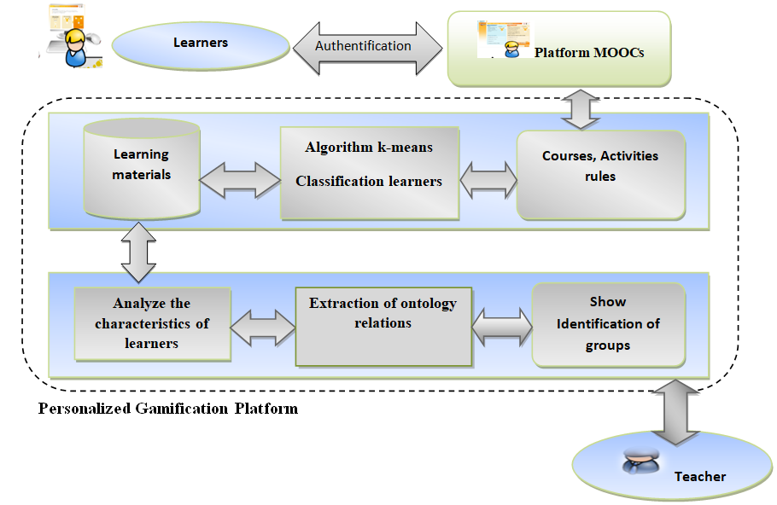
Figure 1 : Proposed Approach
Figure 1 presents the novel approach is implemented in a web application designed for deployment in real-world MOOCs. The personalization process includes:
- Data Collection: Capturing detailed learner interactions such as time spent; quiz performance, and resource usage.
- Clustering: Applying the K-Means algorithm to segment learners into clusters reflecting similar learning behaviors.
- Semantic Enrichment: Utilizing ontologies to assign meaningful labels to clusters, aiding instructor interpretation.
- Instructor Dashboard: Presenting learner clusters and profiles to support tailored pedagogical interventions.
This method reduces the complexity of personalizing at scale by grouping learners and applying targeted strategies per cluster rather than individual-level customization.

C. Integration of Personalized Gasification

To further enhance learner motivation and engagement, the system incorporates personalized gamification architecture. This architecture includes:
- Learner Interface: A simple, intuitive platform interface that encourages consistent engagement.
- Learning Materials Management: Allowing educators to assign customized educational content aligned with learner groups.
- Gamification Engine: Delivering tailored gamified learning paths that include badges, leaderboards, progress rewards, and adaptive feedback mechanisms.
- Clustering and Ontology Modules: Driving personalization by combining behavioral clustering with semantic group identification.
By aligning gamified elements with cluster-specific learner profiles, the system can offer differentiated challenges such as competitive tasks for highly motivated learners and scaffolded exploratory activities for those requiring more support. The dynamic nature of clustering allows continual refinement of personalization as learners progress [36].
In summary, this combined approach of automatic personalization and gamification addresses the core MOOC challenges of retention and motivation, enabling scalable, adaptive learning experiences tailored to diverse learner populations.

- SEMANTIC WEB AND ONTOLOGY- BAZED E-LEARNING PERSONALIZATION

A. Semantic Web and Ontologies in E-Learning
Semantic Semantic Web technologies have significantly advanced the development of machine-interpretable content, playing a crucial role in enabling personalized learning in digital environments. Effective personalization relies on the semantic annotation of educational resources, dynamic adaptation of instructional designs, and individualized content delivery [37]. The central aim of the Semantic Web is to represent information in formal languages interpretable by intelligent agents, thereby supporting the automated discovery, integration, and sharing of knowledge primarily through the use of ontologies.
Ontologies serve as a foundational component of the Semantic Web, offering a formal, shared, and machine-understandable representation of knowledge domains. They allow for the accumulation, reuse, and distribution of knowledge across various abstraction levels using standardized vocabularies collaboratively developed by domain experts. This formalism enables adaptive learning environments to model both subject matter and learner characteristics explicitly, enhancing personalization capabilities.
Recent research underscores the growing importance of ontologies in personalized learning. Learning ontologies help model learner profiles, educational content, and pedagogical strategies, thereby supporting adaptive hypermedia systems in delivering context-aware and personalized educational experiences. Ontology-based frameworks facilitate semantic interoperability, improve content reusability, and leverage reasoning capabilities to enhance learning personalization [38].

B. Ontology-Based Learner Modeling
We propose a Semantic Web ontology-based learner model to represent comprehensive learner information, improving the precision of personalized learning strategies.
Our learner ontology is structured into three sub-models:
- Personal Profile Sub-Model: Captures static learner information such as name, surname, and email.
- Learning Sub-Model: Divided into
  - Knowledge Sub-Model: Tracks domain knowledge, learning objectives, and assessments.
  - Attitude Sub-Model: Represents learning preferences, styles, and affective factors.
- Model Information Sub-Model: Contains metadata on model types and attributes.
Figure 2 depicts the ontology hierarchy illustrating these components.
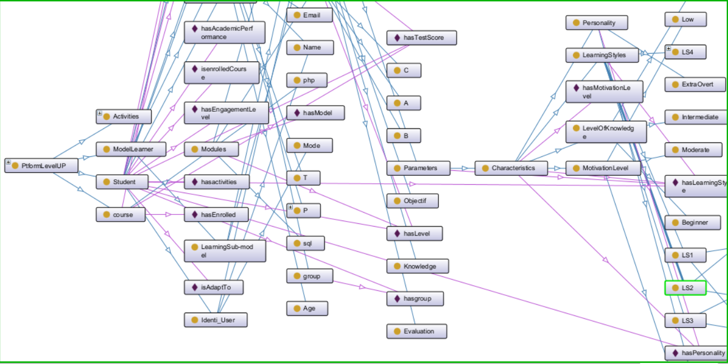
Figure 2: Proposed Platform LevelUP Ontology
The ontology further structures learner representation into facets including user identification, preferences, and personality traits, as shown in Figure 3.
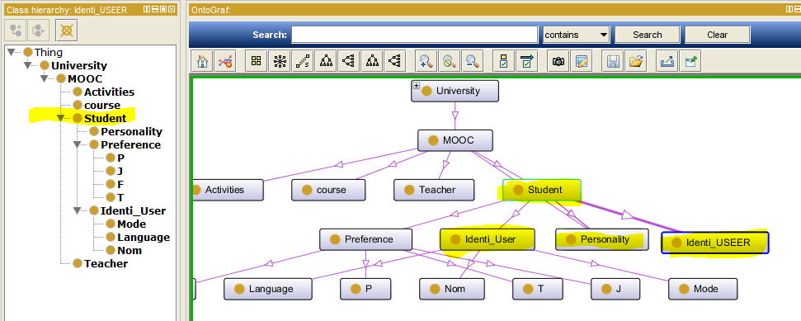
Figure 3: Structure of learner
This enables fine-grained learner profiling essential for optimizing personalization and retention.

C. System Architecture
Our system architecture comprises five integrated layers enabling semantic enrichment, clustering, and adaptive personalization in MOOCs:
Table 4 : Integrated layers
Layer | Components | Functionality
Presentation | LevelUp learner interface, Gamified dashboard | Engages learners with gamified progress tracking, badges, and feedback.
Application | Personalization engine, Clustering module, Rule-based adaptation engine | Implements K-means clustering, executes SWRL rules, and adapts content dynamically.
Ontology Layer | Learner Profile Ontology (OWL), SWRL rules | Encodes learner attributes and reasoning rules to support personalization.
Data Layer | MySQL/PostgreSQL database storing learner logs, task completions, surveys | Collects real-time behavioral and performance data for analysis.
Integration | Middleware (RDFLib, Apache Jena, SPARQL API) | Synchronizes data between database and ontology for continuous updates.
This multi-layer design supports scalable, interoperable, and real-time adaptive learning environments [40].

D. Ontology Structure and Semantic Layer
The ontology model (Figure 3) defines key learner properties critical for clustering and personalization, including classes such as Learner, LearningStyle, MotivationLevel, SkillLevel, CourseModule, and GamificationElement. Object properties (e.g., hasLearningStyle, hasMotivation) and data properties (e.g., hasProgress, hasBadge) enable rich semantic descriptions.
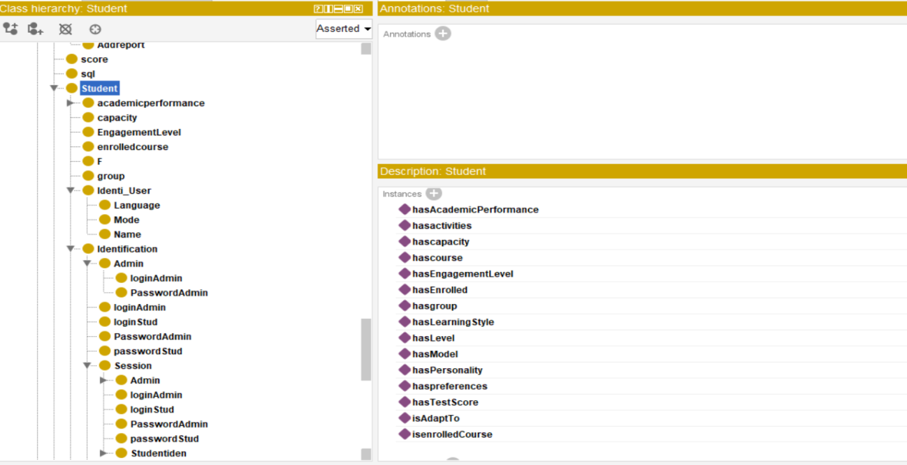
Figure 3: Ontology Learner Proprieties
Example learner instance:
- Learning Style: Visual
- Motivation Level: Moderate
- Progress: 72%
- Badge: Master

E. Semantic Rules and Personalization
Semantic Web Rule Language (SWRL) rules operationalize adaptation by linking learner profiles and clustering results to recommendations. For example:
Learner(?l) ^ hasLearningStyle(?l, Visual) ^ belongsToCluster(?l, HighAchiever) → recommendModule(?m, PHP_AdvancedActivities)
This rule directs the system to recommend advanced PHP modules to visually oriented learners in the High Achiever cluster, enabling context-aware personalized content delivery.

F. Use Case: Adaptive Support for Low-Motivation Learners
The system detects low motivation through behavioral logs and clusters learners accordingly. This approach aims to re-engage learners and improve retention.
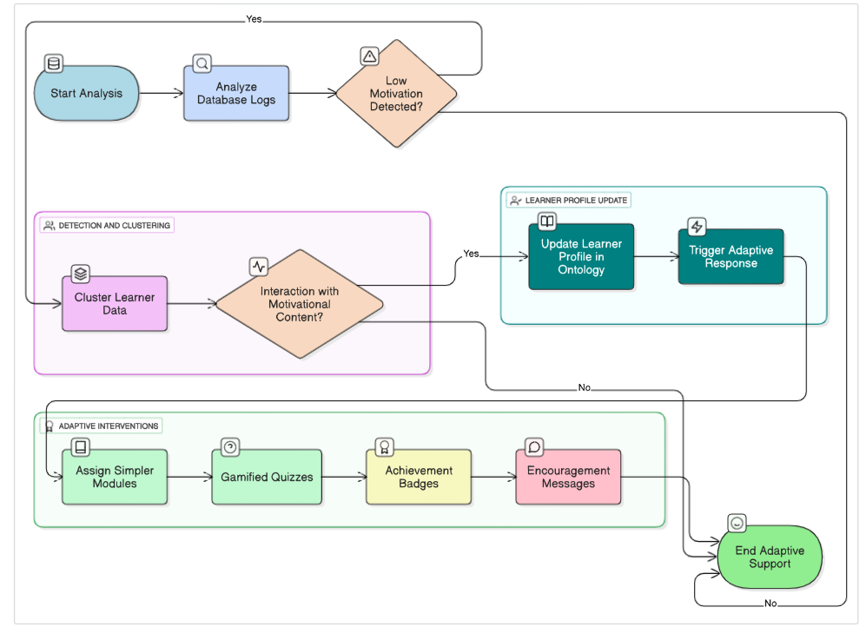
Figure 5: A low-motivation learner
The ontology updates the learner’s profile to reflect motivational needs, triggering adaptive responses such as simpler learning modules; gamified quizzes, achievement badges, and personalized encouragement.

G. Integration Benefits
Table 6 compares the complementary roles of ontologies and databases:
Table 5 : Roles of ontologies and databases
Feature | Ontology | Database
User Preferences & Styles | Explicit semantic modeling | Not directly available
Performance & Engagement | Not directly measured | Behavioral data captured
Personalization Reasoning | Rule-based (SWRL) | Data-driven (ML, K-means)
Adaptive Learning Paths | Semantic profile-driven | Cluster insights for tuning
This integration enables a dynamic, personalized MOOC platform where gamification adapts to individual learner needs, supporting scalable intelligent learning systems [41].

V. Experimentations and Results
This section summarizes three experiments conducted to validate the effectiveness of our personalized gamification framework in MOOCs. The main goal was to assess its impact on motivation, engagement, satisfaction, and academic performance across diverse learning contexts.

1. First Experimentation: University-Level Evaluation at ISET Kairouan
Context: 96 computer science students (ages 19–22) were divided into a control group (traditional method) and an experimental group (gamified learning).
Instruments: Pre/post-tests, Technology Acceptance Model (TAM), Felder-Silverman Learning Styles (ILS).
Results:
- The experimental group outperformed the control group in the post-test (11.83 vs. 10.77 average).
- TAM results showed high satisfaction (Usefulness: 4.9/5).
- ANOVA and t-tests confirmed statistically significant improvement in learning and satisfaction.
- K-means clustering improved personalization by grouping learners based on learning profiles.

2. Second Experimentation: High School Robotics Course Using LevelUp
Context: 63 learners aged 14–18 in an extracurricular robotics club. Learners were divided into 4 groups by learning style.
Personalization Strategy: LevelUp adjusted tasks, feedback, and gamified features dynamically.
Instruments: Platform analytics, motivation scales, satisfaction surveys, interviews.
Results:
- Motivation increased significantly (from 2.9 to 4.1 overall).
- Engagement rose: logins (+137%), task completion (+93%), forum participation (+187%).
- Group C (kinesthetic learners) showed the greatest improvement.
- One-way ANOVA confirmed statistically significant differences in motivation and task completion across groups.
- Learners reported high satisfaction with gamification and personalization features.

3. Third Experimentation: Online PHP Programming via Google Meet
Context: 40 learners (ages 13–18) split into two groups:
- Group G: Gamified version of LevelUp
- Group H: Non-gamified version
Instruments: Motivation scale, PHP test, engagement logs, satisfaction survey.
Results:
- Group G showed higher motivation gains (+1.2 vs. +0.3) and post-test scores (81% vs. 67%).
- Engagement metrics (weekly interactions, session duration, task completion) were significantly higher in Group G.
- Learner satisfaction was greater with gamified features (Overall satisfaction: 4.7/5).
- Suggestions included adding real-time feedback and minimizing distractions from game elements.
Interpretation
Across all three settings, the integration of personalization and gamification using the LevelUp platform and ontology-based learner modeling proved effective. The approach:
- Boosted learner motivation, satisfaction, and performance.
- Was especially beneficial for less motivated or lower-performing learners.
- Validated the importance of adaptive learning environments in MOOCs.

DISCUSSION

A. Summary of Contributions
This study presents a novel approach to enhancing MOOC environments through the integration of gamification and ontology-based personalization. By combining learner profiling, clustering algorithms, and semantic technologies, the proposed system delivers adaptive learning pathways that respond to individual needs. Key contributions include:
- A multi-layered architecture supporting real-time learner profiling and gamified adaptation;
- The use of K-means clustering to group learners and reduce instructional complexity in massive courses;

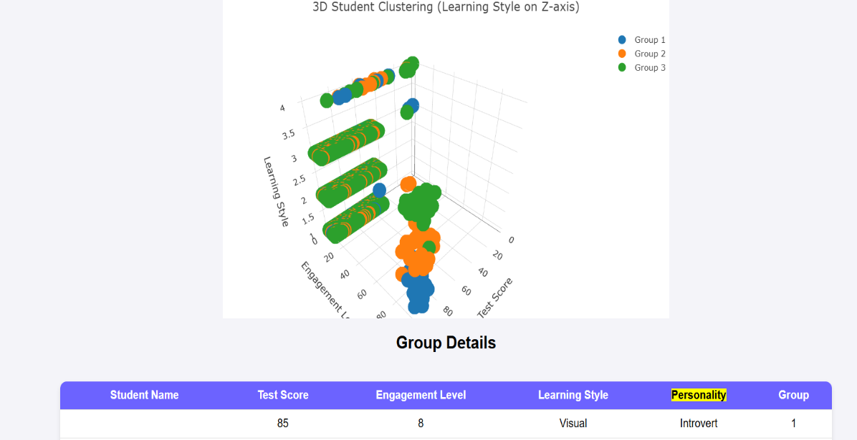
Figure 6: 3D clustering of students in platform LevelUP
Figure 6 presents Dots with the same color represent learners with similar characteristics, grouped into clusters for personalized interventions.
- An ontology-driven learner model that semantically represents user characteristics to support reasoning and personalized recommendation;
- A demonstration of improved learner motivation, participation, and retention through personalized gamification.
These contributions highlight the potential of combining semantic reasoning with behavioral analytics to build intelligent, scalable, and learner-centered MOOC platforms.

B. Future Directions
Building on these promising results, future research should address the following areas:
- Longitudinal Evaluation: Investigate the long-term effects of ontology-based personalization on learner engagement and course completion.
- Advanced AI Integration: Leverage machine learning and reinforcement learning to enhance real-time adaptation and continuously evolve learner models based on complex behavior patterns.
- Cross-Cultural Adaptation: Evaluate the system across diverse linguistic and cultural contexts to assess the generalizability and localization of personalization strategies.
- Extended Gamification Features: Explore the use of immersive gamification (e.g., adaptive narratives, simulations, collaborative challenges) to support deeper engagement and intrinsic motivation.

VI. Conclusion
This study proposed an innovative approach to improving engagement, personalization, and retention in MOOCs by integrating gamification techniques with ontology-based learner modeling. The findings demonstrate that combining semantic technologies with adaptive learning strategies offers a scalable solution for addressing the diverse needs of MOOC learners.
By modeling learner profiles through ontologies and grouping similar learners using unsupervised clustering, the system enables the dynamic delivery of personalized content. This not only improves the quality of learning but also enhances motivation and participation key factors in combating high dropout rates in online learning environments.
The proposed multi-layered architecture supports real-time behavioral tracking, semantic reasoning, and adaptive content delivery. Ontologies facilitate deep learner modeling by encoding preferences, motivation, and learning styles, while clustering techniques help reduce complexity and improve targeting. Together, they form the basis of a personalized gamification platform that responds effectively to learner diversity and behavior.
Despite promising results, challenges such as scalability across large populations, cultural adaptability, and long-term impact remain. Future work should explore the integration of advanced AI techniques (e.g., reinforcement learning), cross-cultural validation, and extended gamification features (e.g., simulations, adaptive storytelling) to further enhance personalization.
Ultimately, this research contributes to the evolution of intelligent learning environments by demonstrating that ontology-driven, data-informed personalization can significantly improve learning experiences in MOOCs. It opens pathways for building adaptive educational systems that are not only scalable but also human-centered, responsive, and pedagogically effective.

References
- Huacui, Y., Zhang, M., & Liu, L. (2024). Addressing learner disengagement in MOOCs through adaptive gamification. Journal of Online Learning Research, 10(1), 33–49.
- Ivone, F., & Eliyanah, U. (2024). Personalized learning strategies in large-scale online education: A cognitive perspective. International Journal of Educational Technology in Higher Education, 21(2), 115–129.
- Galaige, S., & Torrisi-Steele, G. (2024). Designing for learner motivation: Integrating gamified personalization into MOOCs. Australasian Journal of Educational Technology, 40(1), 55–71.
- Halper, R., Nguyen, C., & Baxter, D. (2025). Semantic models and adaptive strategies for scalable MOOC personalization. Computers & Education: Artificial Intelligence, 6, 100152.
- Rodrigues Major, L., & Silva, D. M. (2025). Gamification in higher education: A meta-analysis of learner engagement in MOOCs. Educational Technology Research and Development, 73(3), 1021–1040.
- Carbonell Bernal, I., & Hernández Prados, M. A. (2024). Gamification and personalization in online learning environments: Towards a hybrid model for student success. Computers in Human Behavior Reports, 9, 100127.
- Mohseni, S., Taghiyareh, F., & Badii, A. (2024). Exploring learner features for personalized course recommendations in MOOCs. Journal of Learning Analytics, 11(1), 83–101.
- Kizilcec, R. F., Pérez-Sanagustín, M., & Maldonado, J. J. (2017). Self-regulated learning strategies predict learner behavior and goal attainment in Massive Open Online Courses. Computers & Education, 104, 18–33.
- Kizilcec, R. F., Piech, C., & Schneider, E. (2013). Deconstructing disengagement: Analyzing learner subpopulations in massive open online courses. Proceedings of the Third International Conference on Learning Analytics and Knowledge, 170–179.
- Martin, F., Wang, C., & Sadaf, A. (2013). Student perception of helpfulness of facilitation strategies that enhance instructor presence, connectedness, engagement and learning in online courses. Internet Learning Journal, 2(1), 1–9.
- Aoki, K. (2013). The use of ICT and e-learning in higher education. World Academy of Science, Engineering and Technology, International Journal of Social, Behavioral, Educational, Economic, Business and Industrial Engineering, 7(6), 1695–1699.
- Stine, D. D. (2013). Massive Open Online Courses (MOOCs): Innovation in education? Congressional Research Service, 1–25.
- Kay, J., Reimann, P., Diebold, E., & Kummerfeld, B. (2013). MOOCs: So many learners, so much potential… IEEE Intelligent Systems, 28(3), 70–77.
- Hollands, F. M., & Tirthali, D. (2014). Why do institutions offer MOOCs? Online Learning Journal, 18(3).
- Alario-Hoyos, C., Pérez-Sanagustín, M., Delgado Kloos, C., Parada, G. H., & Muñoz-Organero, M. (2014). Analysing the impact of built-in and external social tools in a MOOC on educational technologies. Proceedings of the European MOOC Stakeholder Summit.
- Bansal, N. (2013). Personalized learning: A reality in MOOCs? International Journal of Computer Applications, 72(17), 1–5.
- Sonwalkar, N. (2013). Adaptive learning for MOOCs: Building personalized learning environments using a pedagogical framework. MOOCs Forum, 1(1), 22–28.
- Kimball, M. (2006). The Web Portfolio Guide: Creating Electronic Portfolios for the Web. Longman.
- Essalmi, F., Jemni Ben Ayed, L., Jemni, M., Kinshuk, & Graf, S. (2010). A fully personalization strategy of E-learning scenarios. Computers in Human Behavior, 26(4), 581–591.
- Rojas, J. A., et al. (2014). Outcome-based discovery and filtering of MOOCs using MOOCRank. Proceedings of the 2nd European MOOC Stakeholder Summit.
- Iftene, A. (2016). MOOC Buddy: A chatbot for personalized learning with MOOCs. RoCHI–International Conference on Human-Computer Interaction, 91.
- Sunar, A. S., et al. (2015). Social interaction in MOOCs: A review of the literature. Proceedings of the 11th International Conference on Web Information Systems and Technologies, 1, 313–318.
- Chakor, Y., et al. (2016). Diagnosing dropout causes in MOOCs using problem/solution trees. International Journal of Emerging Technologies in Learning, 11(11), 58–64.
- Atapattu, T., Falkner, K., & Falkner, N. (2016). Enhancing learning analytics with semantic web technologies for a better understanding of learners’ interactions. Journal of Learning Analytics, 3(2), 115–139.
- Hakami, N. (2017). Investigating learners' perspectives on motivation in MOOCs. International Journal of Emerging Technologies in Learning, 12(11), 107–120.
- Clerc, F., et al. (2015). Persua2MOOC: Persuasive learning in MOOCs. 7th Conference on Computer Environments for Human Learning (EIAH), 144–155.
- Assami, S., et al. (2017). Adaptive recommendation in MOOCs using ontology and rules. International Conference on Smart Learning Environments, 189–200.
- Aebischer, P. (2014). [Missing from reference list – please provide full reference.]
- Stojanovic, L., Staab, S., & Studer, R. (2004). eLearning based on the Semantic Web. Proceedings of the World Conference on the WWW and Internet WebNet, 23–27.
- Drachsler, H., et al. (2015). Ethical and legal challenges of learning analytics. British Journal of Educational Technology, 46(6), 1173–1186.
- Mouhim, A., El Bakkali, H., & Sekkaki, A. (2023). Semantic interoperability and personalized learning: A multi-layer architecture for MOOCs using ontologies and clustering techniques. International Journal of Emerging Technologies in Learning (iJET), 18(5), 112–127.
- Kizilcec, R. F., Piech, C., & Schneider, E. (2013). Deconstructing disengagement: Analyzing learner subpopulations in massive open online courses. Proceedings of the Third International Conference on Learning Analytics and Knowledge (pp. 170–179). ACM. https://doi.org/10.1145/2460296.2460330
- Martin, F., Wang, C., & Sadaf, A. (2013). Student perception of helpfulness of facilitation strategies that enhance instructor presence, connectedness, engagement and learning in online courses. Internet Learning Journal, 2(1), 1–9.
- Aoki, K. (2013). The use of ICT and e-learning in higher education. World Academy of Science, Engineering and Technology International Journal of Social, Behavioral, Educational, Economic, Business and Industrial Engineering, 7(6), 1695–1699.
- Stine, D. D. (2013). Massive Open Online Courses (MOOCs): Innovation in education? Congressional Research Service. https://sgp.fas.org/crs/misc/R43142.pdf
- Kay, J., Reimann, P., Diebold, E., & Kummerfeld, B. (2013). MOOCs: So many learners, so much potential… IEEE Intelligent Systems, 28(3), 70–77. https://doi.org/10.1109/MIS.2013.66
- Hollands, F. M., & Tirthali, D. (2014). Why do institutions offer MOOCs? Online Learning Journal, 18(3), 1–20. https://doi.org/10.24059/olj.v18i3.464
- Alario-Hoyos, C., Pérez-Sanagustín, M., Delgado Kloos, C., Parada, G. H., & Muñoz-Organero, M. (2014). Analysing the impact of built-in and external social tools in a MOOC on educational technologies. Proceedings of the European MOOC Stakeholder Summit (pp. 5–12).
- Bansal, N. (2013). Personalized learning: A reality in MOOCs? International Journal of Computer Applications, 72(17), 1–5. https://doi.org/10.5120/12646-9131
- Sonwalkar, N. (2013). Adaptive learning for MOOCs: Building personalized learning environments using a pedagogical framework. MOOCs Forum, 1(1), 22–28. https://doi.org/10.1089/mooc.2013.0004
- Kimball, M. (2006). The web portfolio guide: Creating electronic portfolios for the web. Boston, MA: Pearson Education.

